<EMG features>

1. Drowsiness detection during different times of day using multiple features [1]  
   - Features:
   1. **Mean values of the spectral power**
   2. **Spectral skewness**
   3. **Spectral kurtosis**

For univariate data $Y_{1}, Y_{2}, ... , Y_{N}$,

$skewness =\frac{\sum_{i=1}^{N}{}(Y_{i}-\bar{Y})^{3}}{(N-1)s^{3}}$, $kurtosis =\frac{\sum_{i=1}^{N}{}(Y_{i}-\bar{Y})^{4}}{(N-1)s^{4}}$

where $\bar{Y}$ is the mean, $s$ is the standard deviation, and $N$ is the number of data points.

Cf. Standard deviation: Consider the signal, $x_{n}$, $n=0,1,2,...,N$, where $N$ is the length of the signal. Standard Deviation: $σ_{X}=\frac{1}{N-1}\sum_{n=1}^{N}{}(X_{n}-μ_{X})^{2}$

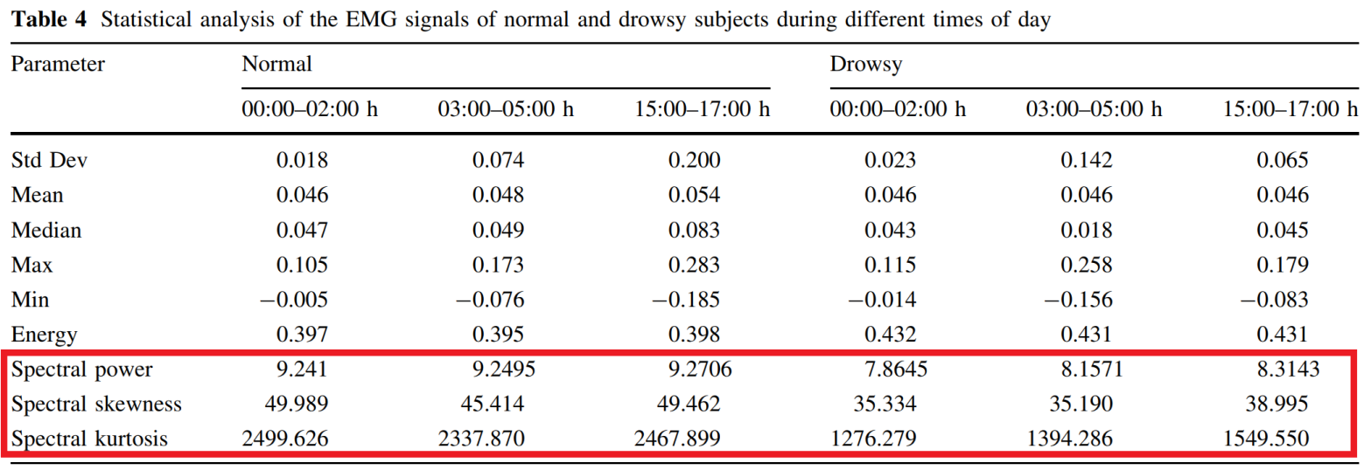

1. [2]

[1]: @article{sahayadhas2013drowsiness,  
 title={Drowsiness detection during different times of day using multiple features},  
 author={Sahayadhas, Arun and Sundaraj, Kenneth and Murugappan, Murugappan},  
 journal={Australasian physical \& engineering sciences in medicine},  
 volume={36},  
 number={2},  
 pages={243--250},  
 year={2013},  
 publisher={Springer}  
}

[2]: